

**PROJECT REPORT**

**Course:** MSCI 100

**Professor:** Kenneth McKay

**TA:** Yash Bhamare and Ashar Kandathil

**Date:** November 16th, 2017

**Team:** 15

**Members:** Austin Sun

Adam Syed

Chi-en (Amy) Tai

Hiba Tawfeeq

Nino Spasik

Richard Uong

**Table of Contents**

1.0 Executive Summary ....................................................................................................3

1.1 Overview …......................................................................................................3

1.2 Approach …......................................................................................................3

2.0 Content …....................................................................................................................4

2.1 Problem …...…................................................................................................4

2.2 Solution ….....................…..............................................................................4

3.0 Description of The Tool …...........................................................................................5

3.1 Assumptions ….................................................................................................5

3.2 Components of The Tool …..............................................................................5

3.3 User Friendliness..............................................................................................12

4.0 Conclusion...................................................................................................................13

5.0 Summary of the group members' contribution ...........................................................15

6.0 Works cited ..................................................................................................................16

7.0 Appendix.....................................................................................................................17

**1.0 Executive Summary**

**1.1 Overview:**

This project assigned Team 15 with the development, design, and construction of an Excel decision support Tool - a system tasked with planning and executing projects such as the MSCI 100 project. The primary objective of this task is to effectively optimize the process of performing a project by functioning as a medium for delegating roles, managing tasks, and providing user friendly interface for group members and their leadership.

**1.2 Approach:**

To begin with, the segments of the design were derived from detailed brainstorming analysis by members of Team 15 through multiple brainstorming sessions. Several detailed designs were illustrated to include Tool logic, features, and functions. A large emphasis was put on the development and planning stage of the project to ensure efficiency and effectiveness. Through discussion, illustration, and other means of planning, the overall delineation of the project formed. Subsequent to the designs developed from the planning stage of the project, the early stages of construction were put into production. Countless upgraded/updated models of the tool were created to add features or to smooth existing components. Early versions of the tool included simple features in the form of singular components. The Tool underwent countless tests to evaluate its functionality and effectiveness. Through these tests, over 20 versions were created to surely improve the overall function of the Tool. Numerous lines of code were implemented into the Tool to repair bugs and add various features that make up a professional assistive device. In order to meet the requirements of an ambiguous decision making device, the Tool was structured and updated accordingly.

**2.0 Content**

**2.1 Problem**

The intent of the MSCI Term Project is to create a decision support tool using Microsoft Excel to support the planning and execution of any group projects. Teams of any interests all around the world face many difficulties before coming to an end/final product. These difficulties may include not knowing the availability of each member, not knowing each members' strengths and weaknesses, or if tasks have been completed or not completed by each member. Moreover, the main potential problem is the lack of the big picture. This point is very important as many groups take the wrong destination because they have not looked at the big picture. This may cause many teams/groups to be very unproductive until the night the final product must be completed which will cause them to "rush" through the final product. In return, the team/group will never be able to progress and evolve to anything better. Their skill levels will stay the same, if not become even worse.

**2.2 Solution**

In order to avoid the problem above, Team 15 has created an effective Decision Support Tool to help the fellow team/group members become as successful as possible. The key functions of the Decision Support Tool is to take in data, manipulate the data, and produce useful information to make group decisions. Each team member will be scored based on competencies. These competency scores will be used to create Development Plan for each member and assign appropriate tasks to these team members. This plan works to enhance each member's skills through the mentor & mentee program. Moreover, it will effectively assign tasks to group members and help each group member grow their skills and competencies.

**3.0 Description of the Tool**

**3.1 Assumptions**

Before creating this Decision Support Tool, the team members had to make a few assumptions in order to make the tool uncomplicated and straightforward.

* + 1. *The Tool cannot support more than 100 members* – The reason being is that this tool has mainly been designed for university, college or high school students. A project like the MSCI project includes only 5-6 members per group.
    2. *Cannot include more than 10 competencies* – The tool must initialize a set number of boxes. However, the boxes can be changed to appear based on the number of different inputted competencies.

**3.2 Components of the Tool**

The tool is composed of several different components:

1. **HOME** - *refer to figure 1.0*

The home is the essentially the ‘hub’ of the tool. It is the first page that the user sees when they open the tool. This page is divided into four major sections;

* **Project Manager** - This section is dedicated to the project manager of the team. It consists of six buttons that direct you to a certain page of the tool:
  + Input Project Tasks - directs the user to the project input page.
  + View Mentor Matching - directs the user to the Mentor Matching page.
  + View Assignment Table - directs the user to the Assignment Table page.
  + Input Resources - directs the user to the Resources page.
  + Problem Sheet - directs the user to the Problem Sheet page.
  + Project Status / Report – directs user to Reports page
* **Member** - This section includes:
  + Input Resources - directs the user to the Problem Sheet page.
  + Update Task Status - directs the user to the assignment table page.
* **Other Shortcuts** – The first button is "View Specific Sheet". When this button is clicked, it gives the user a drop-down menu that lists all the pages in the tool, including the page for each individual team member.
* **Reports –** This section is dedicated to reports and includes:
  + View Member Report – directs the user to a graph/table of all of the work on each assigned task (% level) of all team members
  + View Status Statistics – directs the user to a graph/table of the status statistics of their tasks (how many have been completed, are incomplete, require assistance)
  + View Phase Status – it shows the percent of each task in that phase that is completed

This page is very beneficial to the user. Instead of having to navigating page through all the pages, the user can just navigate from page to page with a click of a button. This page makes the tool much easier to use and eliminates time used navigating from page to page. It gives the user the current date which can serve as a reminder to how much time they have left to complete a various task. In addition, the sections and buttons are clearly labeled with an appropriate font size which increases clarity for the user and color-coded to match the corresponding user forms. Also, all the buttons labelled the same as the corresponding page they direct the user to, which always increases clarity of the hub.

1. **PROBLEM SHEET** *-refer to figure 2.0*

The *Problem Sheet* is a dashboard of sorts which displays necessary information on tasks, deadlines, problem statuses, and assigned members. When the user navigates to this sheet, the user is introduced to a table of information with columns titled *:*

* + *Task, Person, Deadline, Problem Status,* and *Shortcuts*

These columns are relatively straight forward in their display of information, and allows for a user-friendly view of assigned tasks. The *Shortcuts* column features several buttons which function as navigation tools and contains an updating feature.

* + **Task Issues** - this button presents a pop-up window which informs the project manager of outstanding tasks within the current week and navigates the user to the Project Input Sheet. Here, the user can assign tasks to members in the group/team.
  + **View Specific Sheet** - this button introduces a pop-up user form which provides easy access for the project manager to navigate to an interested sheet. *(refer to figure 2.1)*
  + **Update Problem Status** - this button allows the project manager to essentially label each task with its progress. Labels in which the user can assign include 'Addressed', 'Ongoing' and 'Not Addressed'
  + **Return Home** - lastly, this button navigates the user back to the Home Sheet. *(refer to figure 2.2)*

The Problem Sheet is an informative feature that illustrates the countless tasks assigned to each group member and tracks the progress of them. By using this tool, group managers/leaders or even fellow group members can review the progress of the entirety of the group. Having this feature is imperative to the team's success as both a motivational medium and a polite reminder for task completion which ensures the time management of the team. Moreover, it acts as a progress tracker.

1. **PROJECT STATUS/ REPORT**

The *Project Status/Report* is another informative feature that gives a visual of different cumulated in the project. This page has various graphs that organize the following data: Percent of task completion by phase, percent of task completion by team member and status of work completed by team member. These pieces of information help the user to get an all around understanding of the project's progression by looking in depth of each group members progression and also the progression by different phases.

1. **PROJECT INPUT** *-refer to figure 3.0*

This page is only accessible by the project manager. Its main function is to guide the user to input various tasks for the group project and the details of each task. Most of this page consists of a table that organizes the details of each project task. The column headers consist of :

* + *Phase, Task, Task Description, Competency, Competency Skill Level Needed, Time Needed (min), Deadline, Person Assigned and Shortcuts.*

To the right of the table, there is the “Shortcuts” section which includes four buttons;

* + **Project Phase and Task Input** - When this button is clicked, a user form appears and asks the user to input three pieces of information. Firstly, the tool asks the user to input the number of team members including themselves. Secondly, the user is asked to input the number of weeks dedicated to the project. Lastly, the tool asks the user to select the final deadline of the project. The user selects the date from a calendar. *(refer to figure 3.1)*
  + **Add New Task** - this button asks the user to fill in various details about the new task they want to present in the project. The details that the user must fill out are as follows: Selecting which project phase the task is under, the task itself, crucial descriptions of the task, competency needed to complete the task, skill level needed in the competency that the user just inputted, estimated time to complete the task and the deadline of the task. These characteristics are then displayed on the table. *(refer to figure 3.2)*
  + **Match Tasks to Team Member** - this button which assigns a task inputted by the project manager to the group member that is has the appropriate credentials to complete the given task. The criteria that the project member established for a specific task must be met by a group member to get matched up with that specific task the logic process of matching a group member with a specific task is as follows: Does the group member have enough available time per week to work on the task based on the time estimated to complete the task (inputted by project manager), if no then the group member is immediately taken out of consideration to be paired up with the task. Then, the group member that has the same level of competency that is needed for the specific task is matched with the task, if there is more than one matched member then one of them is selected based on alphabetical order. If there are no group members that have the same skill level required, then group members that have the skill level closest and higher than the required skill level for the chosen competency is paired. Once again, if there is more than one member that meets the expectation, then one is selected by alphabetical order. Finally, if there are still no members matched after these logic processes, then the member with the closest and lower skill level than the skill level needed for the specific competency is paired. Alphabetical order once again will be used to determine the matched person if there are more than one matched members.
  + **Edit Task Inputs** - this button lets the user select an already created task and let’s them edit the details about it. The user form is the same as the one the “Add New Task” button displays. *(refer to figure 3.3)*
  + **Return Home** - directs the user back to the Home page of the tool.

This page is very key to the project manager since this is where every task of the project is created. The clearly labelled diagram organizes all the details about the task, so the project manager can easily refer to them. The simple design of this page makes it easy to navigate and find the information you are searching for. The “Edit Task Inputs” button is a useful feature since the user can always go back to any tasks and adjust them, instead of having to delete the task and have to make a new one. The buttons are clearly labelled, and the user can easily understand the function of each button.

1. **RESOURCES** *-refer to figure 4.0*

The Resources Sheet displays a table for the project manager to view team members, their competencies, and their available times. The available times are also updated when the workbook is opened to account for any undistributed/ "unused" time in the past by taking the overall project deadline, the current date, and the time of any tasks assigned to each member. This sheet increases the effectiveness of project managers in monitoring all group members' availability as well as their ability to perform tasks outlined by the project. The table in this sheet include the following:

* + *First Name, Last Name, Email, Available Time/Week (min), Total Available Time (min), Competency Titles, Additional Comments,* and *Shortcuts* respectively.

The 'Comp' columns represent the competencies which were inputted as described in the user manual. These columns are originally hidden and revealed as a new competency is introduced in the project tasks. Each time a task is matched to a member, this table is updated to show the reflection in amount of available time. The table in this sheet essentially displays the information of all group members including their capabilities for project managers to manipulate tasks accordingly. The Shortcuts column contain several buttons including

* + *Add New User, Edit Resources, Update Member Sheets, and Return Home.*

The ‘Add New User’ button activates a pop-up user form titled ‘Team Member Survey’, which is used by the project manager to add a new member and the following information that would come with them. *(refer to figure 4.1)* The first name, last name, email, and availability by hours per week is recorded in the ‘Team Member Survey’, as well as the levels of competency. The ‘Edit Resources’ feature allows the members to revise any of their previous input. *(refer to figure 4.2)* For instance, they can change their available time or email. When they click submit, the table is updated to reflect those changes. When the ‘Update Member Sheets’ button is clicked, a copy of the Individual Members Sheet is created for each team member. This sheet is useful in displaying pertinent information specific to each member.

1. **MENTOR MATCHING** *-refer to figure 5.0*

The *Mentor Matching* page allows group members who are considered mentors to pair up with group members who are considered mentees of a specific competency. This tool will go through all the competencies that were inputted and review the corresponding member scores to each competency. If there is a person with a specific competency of 1 or 2, then they will be matched with another member, with a competency of 5 or 4. However, if there are no users with a specific competency of 1 or 2, then no mentor/mentee matching will occur. Additionally, if there are no mentors available, the program will notify the user of such an event. The logic process when pairing up a mentor and a mentee for a given competency is as follows:

* 1. Firstly, all members in that competency are searched to see if they have a score of 1. If there are no members with a score of 1, then the members are searched to see if someone has a score of 2. If no one has a score of 1 or 2, then no matching occurs as it is not needed.
  2. However, if there is a person with a 1 or 2 competency score, then they are labelled as a "mentee" for that competency. The program then searches all the members to see if a person has a score of 5 in that specific competency. If there is a match, that person becomes a "mentor" for that competency.
  3. If no one has a skill level of 5, then the program searches for someone with a score level of 4. If there is such a person, then that member becomes the "mentor" for that competency. If there is no such person, then the program notifies the users that there are no mentors available.

In addition, this page has an “Assign Roles” button which simply runs the logic process of mentor/mentee pairing and displays the group members names on a table. The table displays the mentor and mentee for each of the competencies. The “Return Home” button simply directs the user back to the Home page.

1. **ASSIGNMENT TABLE** *-refer to figure 6.0*

The *Assignment Table* Sheet serves as a summary sheet for the project manager and the team members. is reason it is accessed by the project manager and the all team members. This sheet ensures that all the tasks, completion and due dates assigned for each team member are up to date. As seen, there are ten columns in total, each column gives specific information:

* + **Phase -** Indicates which phase.
  + **Task -** The first column splits into multiple rows and each row is designated to a specific task that has been assigned.
  + **Task Description -** A brief description of what each task is about should be shown here.
  + **Name** - Shows the first and last name of the person that has been given the task.
  + **Time needed (min) -** This column calculates the approximate time needed to complete each task. The time is continuously updated by clicking on the "update button", which subtracts the time the corresponding member has spent on the task from the total time originally needed.
  + **Time Worked (min)** - When each member continuously update their sheet of how much time they have spent on their task, that time should be shown here.
  + **Status** - This is to give a whole summary of how each member has been doing. It is also divided into three components:
    - *Completed* - shows up as light green.
    - *Incomplete* - shows up as light yellow.
    - *Require Assistance* - shows up as red which serves as "alert" for the project manager who has to deal with this issue right away.
  + **% completed project level (by time)** - This column will calculate the percentage of how much time has been spent on the task assigned by each member based on time spent and needed time for the task.
  + **Deadline** Only shows the deadline that the task assigned to each member must be completed by.
  + **Shortcuts -** Is another feature that has been split into three components.
    - *Update Table -* By clicking on this, the sheet is automatically updated and therefore, the member or the project manager will always have access to the updated summary sheet
    - *Task Update -* The member can click on this button to add a task or update the task that they have been working on. By clicking on the button, the member will input their updated information so it is shown on the summary sheet. (refer to figure 6.1)
    - *Return Home -* this button is a shortcut to get back to the main page, the hub

This sheet is very effective as it allows the managers to get an idea of how the project and the whole group is doing. If there are any issues with a specific team member, the project manager will directly be able to see it through the colours of each status. This will further allow easier and faster communication with the group.

1. **INDIVIDUAL MEMBER SHEET**

When clicked on this button, a very similar page to the *Assignment Table* page will be displayed, the only difference however is that it is corresponded to a specific team member. Once clicked on the button, one will get one option of which member sheet to view. Once an option has been selected, it will direct the person to a page filled with the updated information of the selected member. The member can update their table to see any more updated tasks and also, return back to home page.

1. **MEMBER REPORT**

The *Member Report* page provides the user with more graphic information. It displays an updated graph of percent of task completion by each member. This is another visual aid to help the user see the "big picture" of the project's progression and to also monitor each member's contributions to the project.

1. **CURRENT STATUS**

This button will take any member to a graphic page showing *status of work completed by each team members.* It will show a summary table and its corresponding summary chart. The summary chart will also include the 'grand total' of each status. This page is very effective as it allows the members and the manager to get an idea of how the group as a whole is doing.

**3.3 User Friendliness**

It is important for assistive devices, programs, and tools to have an aesthetic image and user friendly interface. Not only does it give users a professional and pleasing experience, having a visually appealing Tool allows for more efficient navigation and effective user interaction. User friendliness makes the user experience less frustrating and streamlines the efficiency of members.

* + **Color Coding -** Coloring of the Tool is an effective way to give a professional and visually pleasing aesthetic to the Tool. Several color coatings increase the user interface experience
    - **Blue -** Represents buttons and other features related to project managers. Project managers can use this color to navigate the Tool and find features built specially for them.
    - **Purple -** Similar to the blue coloring of the member features, project managers can follow purple coloring of buttons and features to navigate the tool.
  + **Error Prevention -** An additional feature added to the program allows users to input information into any user form without the fear of program errors. Essentially, the Tool is designed to prevent users from inputting incorrect data and suggests an appropriate input instead. For instance, if a user tries to enter a letter, instead of a number, a message box will pop up to remind the user of the correct input format. Another example occurs when the user tries to view the assignment table without the input of any tasks. This program will immediately bring up a pop-up box to remind the user to have their project manager input various tasks.

**4.0 Conclusion**

Whether in a workplace or in school, people will be put together to complete certain tasks together. This does not always work out properly as many problems show up. Potential problems that a team may face could be, bad time management, insufficient communication, difficulty completing tasks and, lack of 'big picture'. These problems will not lead to any progress or improvements as the team may be very unproductive until the night of the due date of the project/task. This is the reason why Team 15 has creating an effective Decision Support Tool using Microsoft Excel. The key functions of the Decision Support Tool is to take in data, manipulate the data, and produce useful information to make group decisions. Team 15 is hoping that this tool will benefit each team member and evolve their skills to the next level.

**5.0 Summary of Group Members' Contribution**

In order to complete a successful group project, each group member must contribute equally to the work of the project. This is exactly what Team 15 has been doing. Show below is a description of each member's role, and exactly how they contributed to this term project.

**ADAM SYED & AUSTIN SUN**: These two members have been the so called *software developers (coders)* The beginning stages of the decision support tool has been done by Adam and Austin but Austin then transitioned to assist with graphics and content with the help of some coding knowledge. Amy replaced Austin as a coder for the final product. The ideas that have been created by the whole team has been put into action by them.

**AMY TAI**: Since the beginning of this term, Amy has been the so called *project manager* who has been taking care of the meeting times, preparing the outline for each meeting, making sure that everything is done on time and that everyone has always something to do. She has also been helping Adam Syed and Austin Sun with the programming of the teams decision support tool.

**HIBA TAWFEEQ**: Has been responsible for ensuring that the tool is attractive and organized. She has been designing the general layout of the tool with assistance from the software developers to ensure that it is feasible and connected to the actual tool. Her job has also been to create any graphics and charts related to the tool.

**NINO SPASIK**: Has been responsible for ensuring that each members ideas are shown in the report for the project. Nino takes the ideas and finalize it to a final product through writing and editing the final output before submitting it in order to avoid any errors. Moreover, he has been helping the visual designer with the creation of any graphics or designs.

**RICHARD UONG:** Is the teams *content specialist* who has been gathering and researching all the information needed for the tool and the reports that have been previously submitted. Richard has been the teams main report writer, and with help from Nino Spasik, he takes the big idea from the group and put into words.

**6.0 Works Cited**

“Auto Resize Zoom Feature.” *OzGrid*, OzGrid, 20 Mar. 2006, www.ozgrid.com/forum/forum/help-forums/excel-general/39159-auto-resize-zoom-feature.

Carney, Ken. “Excel VBA Programming.” *Excel VBA Programming*, Home & Learn, www.homeandlearn.org/multidimensional_arrays.html.

“Declare Active Worksheet Variable in VBA.” *Excel - Declare Active Worksheet Variable in VBA* , Stackoverflow, 26 May 2015, stackoverflow.com/questions/30466233/declare-active-worksheet-variable-in-vba.

Dion, Joe. “Excel Form VBA Combobox Reset.” *Excel Form VBA Combobox Reset - Stack Overflow*, Stackoverflow, 8 Sept. 2015, stackoverflow.com/questions/32465225/excel-form-vba-combobox-reset.

“Finding Max of a Column in VBA.” *Finding Max of a Column in VBA*, Stackoverflow, 6 Mar. 2017, stackoverflow.com/questions/42633273/finding-max-of-a-column-in-vba.

“How to Use DATEDIFF to Return Year, Month and Day?” *Sql - How to Use DATEDIFF- Stack Overflow*, Stackoverflow, 9 Oct. 2009, stackoverflow.com/questions/1541570/how-to-use-datediff-to-return-year-month-and-day.

jascforfunI agreed to these rulesJoin Date: 14th July 2006Posts: 11, and KrishnakumarSuper ModeratorOzMVPJoin Date: 18th November 2004Posts: 4689. “Announcement.” *List All Worksheet Names - Free Excel\VBA Help Forum*, OzGrid, 5 Dec. 2006, www.ozgrid.com/forum/forum/help-forums/excel-general/52431-list-all-worksheet-names.

“MS Excel: How to Use the ABS Function (WS, VBA).” *MS Excel: How to Use the ABS Function (WS, VBA)*, TechontheNet, www.techonthenet.com/excel/formulas/abs.php.

Strasburger, Oskar. “VBA Excel, Mismatch for Inputbox as Integer.” *VBA Excel - Stack Overflow*, Stackoverflow, 11 Feb. 2013, stackoverflow.com/questions/14809830/vba-excel-mismatch-for-inputbox-as-integer.

“Visual Basic Reference.” *Unload Statement*, Microsoft, msdn.microsoft.com/en-us/library/aa445829(v=vs.60).aspx.

www.techonthenet.com. “MS Excel: How to Use the DATEDIFF Function (VBA).” *MS Excel: How to Use the DATEDIFF Function (VBA)*, TechontheNet, www.techonthenet.com/excel/formulas/datediff.php.

Wyatt, Allen. “Running Macros on Hidden Worksheets.” *Tips.net*, Tips, 5 May 2016, excelribbon.tips.net/T009329_Running_Macros_on_Hidden_Worksheets.html.

**7.0 Appendix**

***Figure 1.0*** 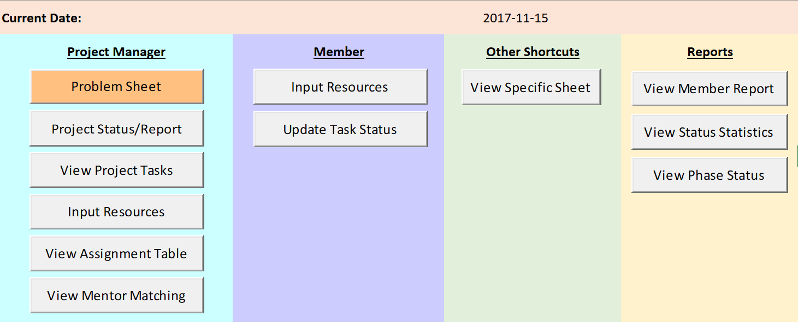

***Figure 2.0***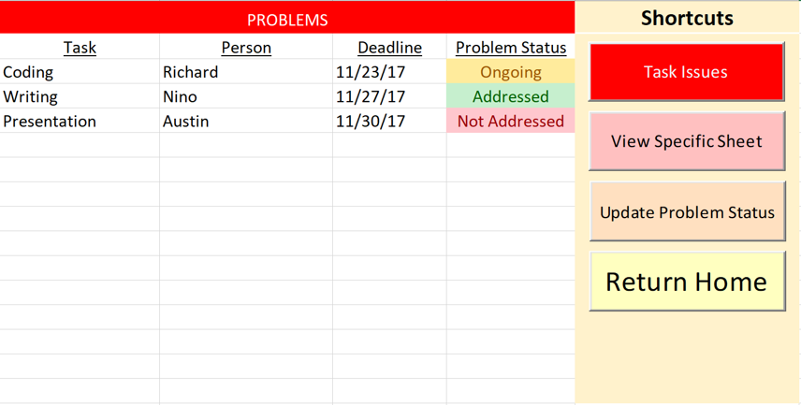

***Figure 2.1***

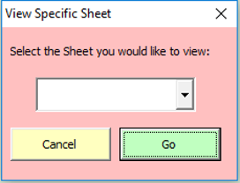

***Figure 2.2***

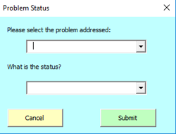

***Figure 3.0***

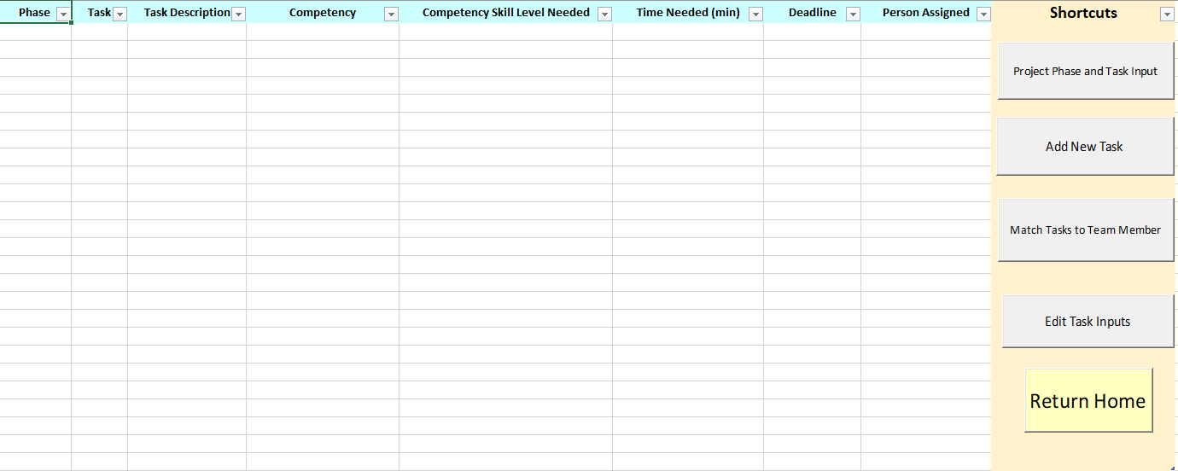

***Figure 3.1***

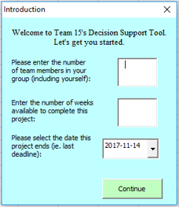

***Figure 3.2***

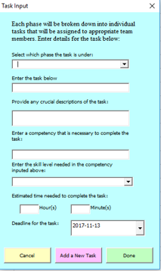

***Figure 3.3***

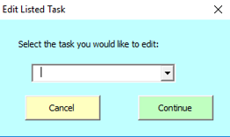

***Figure 4.0***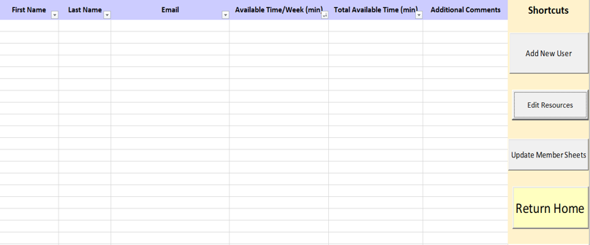

***Figure 4.1***

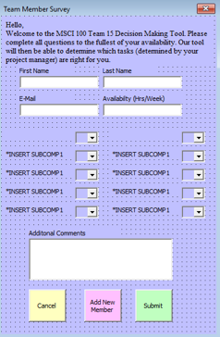

***Figure 4.2***

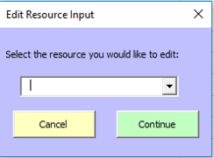

***Figure 5.0***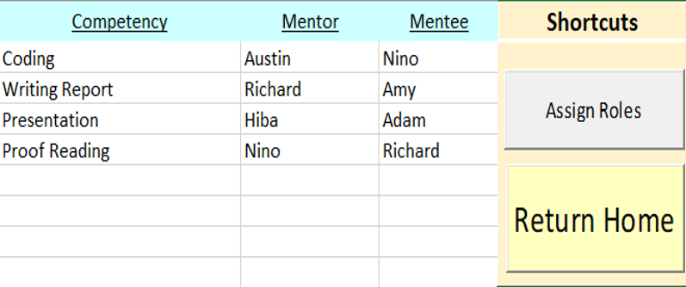

***Figure 6.0***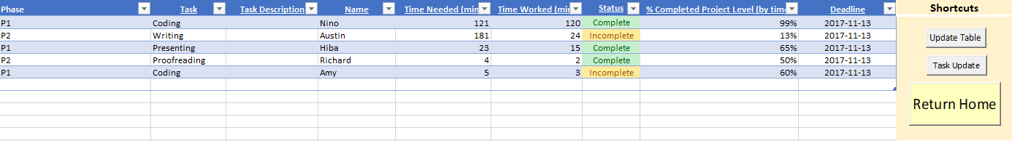

***Figure 6.1***

